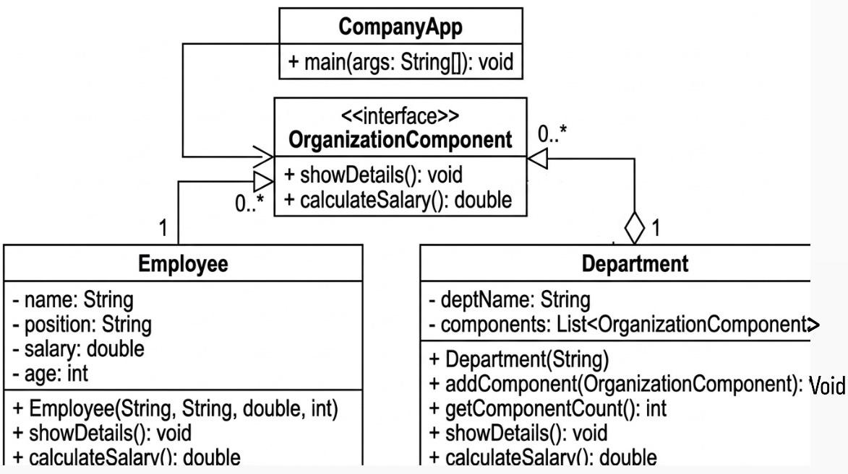

How the pattern is applied in the solution:
• Component (OrganizationComponent): This interface serves as the base abstraction for all elements in the hierarchy. It declares the common operations: showDetails() and calculateSalary(), ensuring that both employees and departments follow the same contract.
• Leaf (Employee): The Employee class represents the leaf nodes of the tree. It implements the business logic for a single unit. In this context, calculateSalary() returns the individual's salary directly, as it has no children to delegate to.
• Composite (Department): The Department class acts as the container (Composite). It maintains a collection of OrganizationComponent objects. The power of this pattern is evident in its implementation of the methods:
• Delegation: When calculateSalary() is called on a department, it does not calculate a single value; instead, it iterates through its list of components and recursively triggers their calculation logic.
• Recursive Structure: Since the list contains the interface type, a department can hold both Employee objects and other Department objects (sub-departments), allowing for an infinitely nesting organizational tree.

